Outreach Programs • Delivery Variations

The First Tee programs are designed to be valuable additions to your school and community programs! Below is a list of strategies to assist instructors with implementing program activities into a variety of challenging teaching and coaching situations.

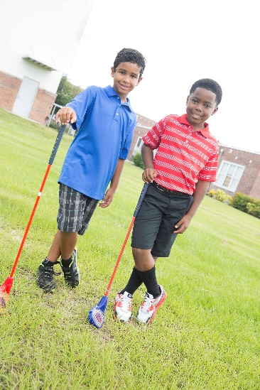
1. Ready — Set-Up — Go! Ideas for setting up equipment quickly:
  - Use the same set-up all day, for all age groups — between classes, quickly adjust targets closer or farther from players depending on age.
  - Teach student-helpers to assist with set-up and quick changes. Assign helpers as a way to reward or recognize positive and/or safe behaviors.
  - Utilize “instant activities” or easy, “go-to” games that players know and can do independently or in small groups, while the instructor finishes set-up.
  - Use floor tape as markers to “save” the layout from one day to the next.
  - Organize only the equipment needed for specific lessons or games. Prepare components in station packs so each pack has the specific clubs, targets, balls, color cones, hoops, etc., needed for that station.

2. Golf Instructions Simplified! Effective ways to teach golf skills:
- Remember that your entire focus is to make golf SAFE and FUN! If it’s safe, you and parents like it, if it’s FUN, your players will LOVE it. (Opposite of fun: Too many instructions and expectations of “perfect” performance.)
- Let children explore how to use a club to make a ball reach the target. For example, use the same method you would use if teaching someone to ride a bike – “give it a go!”
- Review instructional cue cards from the manual and practice the motions while mirroring the photos.
- Have a student demonstrate while you read the cues.
- Contact a local chapter of The First Tee and ask for support.
- Go to a golf course, driving range, putt-putt course to practice.
- Research golf for children (videos, YouTube, apps) then show the video rather than trying to do it yourself.
- Invite a golf professional or a coach from The First Tee to your school to assist.
- Relate golf skills to other, more familiar sports and skills.
- Short or long throw as in short or long strike with a club
- Set up to the ball and align to a target as in batting in baseball/softball
- Backswing, through to contact and follow through as in baseball and tennis

3. Adjustments for 30 Minute Classes
- Set up duplicate stations with the same activity. Players will not need to rotate to every station which will save time while allowing everyone a chance to play.
- Adjust the amount of balls used from three to two to allow players to take turns more quickly.
- Number each station clearly to minimize confusion during rotation.
- Color-code balls with caddy hoops at each station. Players rotate to the next station and find the position with the same color balls and same color hoops used at the previous station.
- Mix a golf station or two in with other stations that include familiar, easy to play activities.
  - Putting with rolling stations
  - Chipping with low, medium, high bounce stations
  - Pitching with lofting the ball in the air as in basketball or soccer
  - Full swing with throwing or kicking for distance, height or accuracy
- Consider a class of only Healthy Habit warm-up activities or use them in conjunction with other lessons/games that need less time to play.

4. Enhancing Safety
- Review and consistently implement your established class protocols.
- Use clubs ONLY when players demonstrate a willingness to follow safety protocols — players earn the chance to use clubs by following the safety rules. They also may quickly “un-earn” them if behavior slips.
- Limit amount of equipment available to players. Place clubs at one or two stations rather than all four.
- Do not use clubs at all. Play activities by rolling, tossing, throwing the balls instead! Safety FIRST!
- Teach only putting and chipping games.
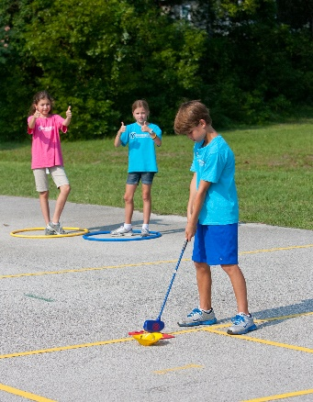
- Teach golf outdoors to allow for additional space between players and stations.
- Teach, reteach and practice the 5 Layers of Safety:
  - 10 feet between players
  - Club down when switching with partners
  - ABC’s before swinging a club
  - Act out the core value behavior of the day
  - Follow the general class safety protocols established by the instructor
- Color-code balls with caddy hoops at each station. Players rotate to the next station and find the position with the same color balls and hoops used at the previous station.
- Place a row of cones between stations to clearly mark areas of play.

5. More is More and Less is More! Managing large classes in small (or large) spaces:
- Limit amount of equipment available to players. Place clubs at one or two stations rather than all four.
- Mix a golf station or two in with other stations that include familiar, easy to play, player-directed activities — like fitness stations.
- Set up additional stations and/or targets such as: large hoops, milk crates, parachutes, dome cones.
- If available, teach outdoors in large open area.
- If you have a team-instructor, divide group in half — one instructor teaching golf activities, while instructional partner delivers another sport or game.
- Work on a set of stations that fit your space and use repeatedly.
- Organize in groups of three partners — ONE player with the club and TWO caddies in the safety hoop.
- Have players hit into a parachute or two. Place players at every other color (good for chipping) and the balls do not roll off the parachute.

Resources
- The First Tee National School Program (NSP) Curriculum Manual 2.0
- The First Tee DRIVE Activity Guide
- The First Tee website: www.thefirsttee.org
- PE Central: www.PECentral.org
- Contact: Benna Cail, bcail@thefirsttee.org

